STEPS TO INSTALL AND MANAGE VMs USING KVM/QEMU

1. Installing KVM/QEMU

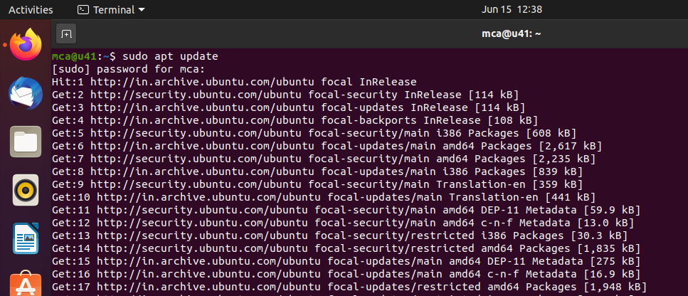

1. egrep -c '(vmx|svm)' /proc/cpuinfo

2. sudo apt install cpu-checker

3. sudo kvm-ok

4. sudo apt install qemu-kvm libvirt-daemon-system libvirt-clients

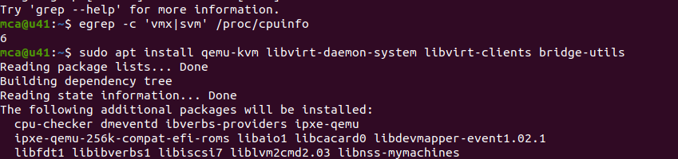

5. sudo systemctl status libvirtd

6. sudo systemctl enable --now libvirtd

7. sudo apt install virt-manager

8. sudo virt-manager

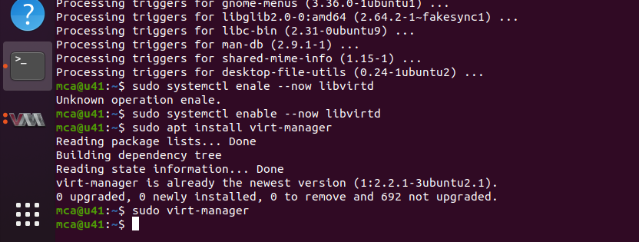

1. Installing VM - using ISO image

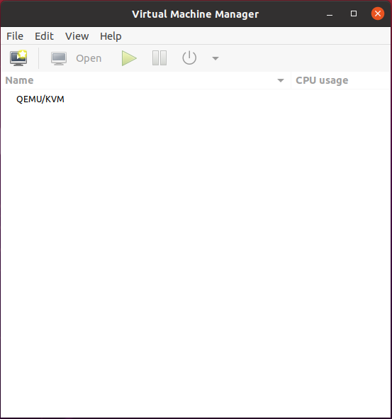

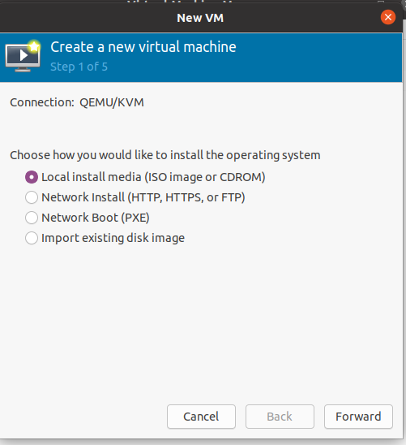

1. Managing VMs using Virt-Manager
2. sudo virsh list

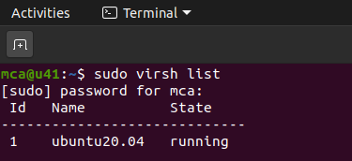

2. sudo virsh list –all

https://lh5.googleusercontent.com/ZeO48Oy-NJ8Qc0JMz9CvPtBYQ-Ci1qK6Tg5wI-S2-lr0-PPYjOsmII3jqucd85k4TFEcVbP7TLCD_MGQDIgCyu0eFyRlsvNYgWPKoOYBb3utTveuHeZvBkyAjVIpfFew_pjGgo44VAdFNIKx-b8giW8

3. sudo virsh nodeinfo

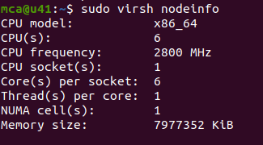

1. sudo virsh help list

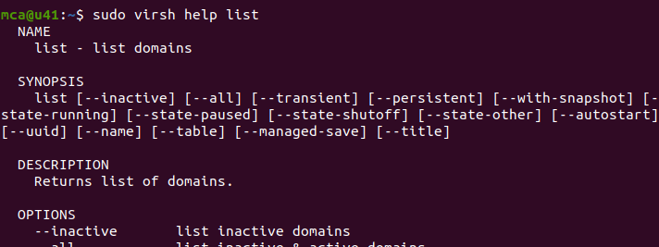

1. sudo virsh start <vmname>

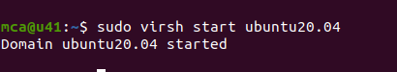

1. sudo virsh reboot <vmname>

https://lh3.googleusercontent.com/pf6n68ilheq31g0p5ayr5FATw5Sm49sX1sLf4UroEl__KxlHfMx_4K12p1qxMLFwH_IrbLYkD_4NN8gbjBV_SaiDGefNyWQFZPNQFPGAokVs4vB8GeKfTxMOzitnzlZB4sipC3tOYIcgBUe9ERsM-3U

1. sudo virsh dominfo <vmname>

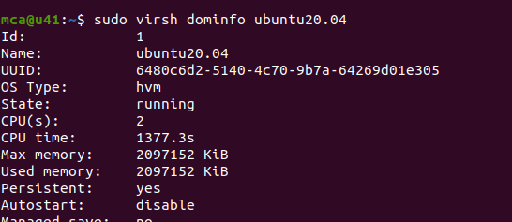

1. sudo virsh suspend <vmname>

https://lh6.googleusercontent.com/iLaud18seXAfen_RGotouzeTcxqnMa4gsJ3I7XvQIggTmZns2ANjvxiaEn4n3UX6RHxPMqO1X2Rm4T-zkgY8TzZdQbMm1lOo0wYbwUaBa-4XUT1wlv1UTvgbN71OwbsAhUlAGoJ52ZYiWFZE1Ly1Keg

1. sudo virsh resume <vmname>

https://lh3.googleusercontent.com/YsieeR6-fuwYTNQbsHAAI3I-RMGDPjg8kaWTVtyKyZrwPsFYf_xnFQ_yrM8Dc3xVnmX5Im0xQHe4QClej1H4A-ZCr_FC7ppWfRM7lJWzJDO3TfVZ78DyTrc_FNYRGd2fTYvXH0kVZx0KZb8JNcIPL34

1. sudo virsh shutdown <vmname>

https://lh5.googleusercontent.com/GMb16Mij4rZl5cUhMHJjH88RjDMmr93X42IaXB2xbv1figHPRj_C1AHqRFxbAs5Uk8dj1wTPc9wfOAGfyZz5LKV_9S9Oi45lbiDIs4WRRJSsl1mjLC8IPfPBJ6Py2Fethq4Lh_rk5Kv6a58n4dHvmw8

1. sudo virsh destroy <vmname>

https://lh5.googleusercontent.com/sqYLp-gnwvwXVsOPmx5EasmRIh-Sy8-xhIPx0WI1w1zFHfwIpti72koKRNaTrSTKLkZk_59qxk7Dk0OVvDHKKI5LyTyuIexybbufjGCDz5ARqitK17_88jch2w-KR5dPPx3WGl80lT5ZLEZQ6QZKZF8

1. sudo virsh undefine --domain <vmname> --remove-all-storage

